**PandasAssignment**

Q1. How do you load a CSV file into a Pandas DataFrame?

ANS:Use pandas.read_csv( ) function is used to load csv file.

*#reading data in pandas*

import pandas as pd

df=pd.read_csv("https://raw.githubusercontent.com/datasciencedojo/datasets/master/titanic.csv")

df

Q2. How do you check the data type of a column in a Pandas DataFrame?

ANS: we can use dtype attribute to check data type of a column in a Pandas DataFrame

Q3. How do you select rows from a Pandas DataFrame based on a condition?

ANS:Using loc() attribute we can select rows from a Pandas DataFrame based on a condition

df.loc[100]

Q4. How do you rename columns in a Pandas DataFrame?

ANS:Using rename() function we can rename columns in a Pandas DataFrame.

Q5. How do you drop columns in a Pandas DataFrame?

ANS:Using drop() function we can drop columns in a Pandas DataFrame.for example

*#deleting the column*

df.drop('new_col', axis=1)

Q6. How do you find the unique values in a column of a Pandas DataFrame?

ANS:Using unique () function,we can find unique values in column of a Pandas DataFrame

df['Pclass'].unique()

Q7. How do you find the number of missing values in each column of a Pandas DataFrame?

ANS: isnull() function used to find the number of missing values in each column of a Pandas DataFrame { df.isnull()}

Q8. How do you fill missing values in a Pandas DataFrame with a specific value?

ANS: Using fillna() method we can fill missing values in a Pandas DataFrame with a specific value df['Pclass'].fillna(0,inplace=True)

Q9. How do you concatenate two Pandas DataFrames?

ANS:Using concat() method,we can concatenate two Pandas DataFrames

frames = [df, df1]

res1 = pd.concat(frames)

res1

Q10. How do you merge two Pandas DataFrames on a specific column?

ANS:Using merge () function ,we can merge two Pandas DataFrames on a specific column

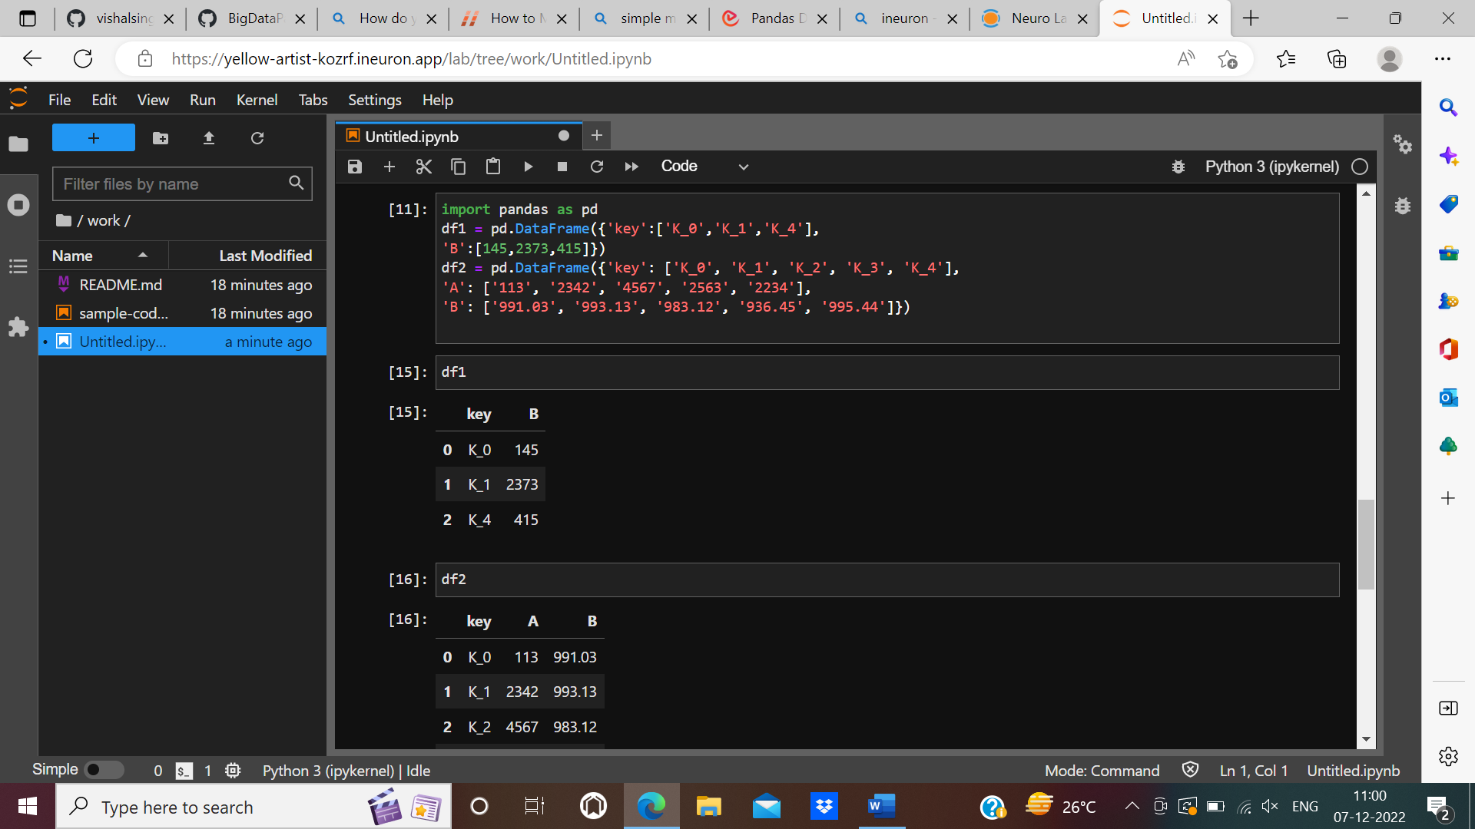

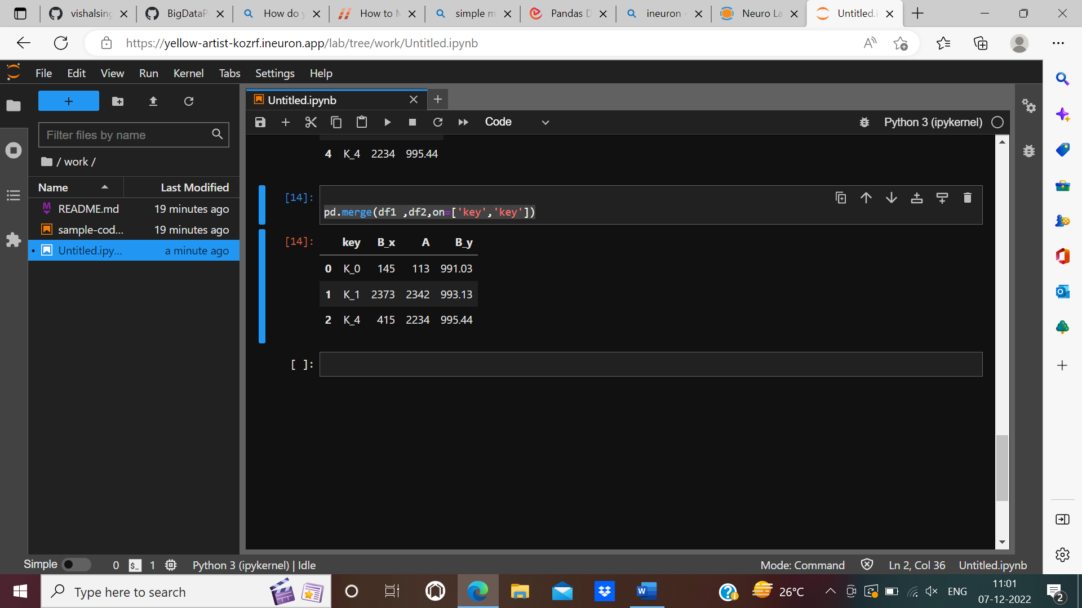

Q11. How do you group data in a Pandas DataFrame by a specific column and apply an aggregation function?

ANS:Using groupby() function , we can group data in a Pandas DataFrame by a specific column.

df.groupby('Name')

print(df.groupby('Name').groups)

Q12. How do you pivot a Pandas DataFrame?

ANS: We pivot a pandas dataframe using below format so that refined data.

DataFrame.pivot(*, index=None, columns=None, values=None)

Q13. How do you change the data type of a column in a Pandas DataFrame?

ANS:To change the data type of a column in a pandas data frame ,we use

Dataframe.astype()method

Q14. How do you sort a Pandas DataFrame by a specific column?

ANS: To sort a Pandas Data Frame by a specific column, use pandas.Dataframe.sort_values()

Method with argument by=column_name.

Q15. How do you create a copy of a Pandas DataFrame?

ANS: To create a copy of a Pandas DataFrame we use copy() function.

Q16. How do you filter rows of a Pandas DataFrame by multiple conditions?

ANS: We filter rows of a pandas Data Frame by multiple conditions ,using string methods, missing value, query, slice, logical condition etc,

Q17. How do you calculate the mean of a column in a Pandas DataFrame?

ANS: Using Dataframe.mean(),we calculate the mean of a column in a Pandas DataFrame.

Q18. How do you calculate the standard deviation of a column in a Pandas DataFrame?

ANS: Using Dataframe.std(),we calculate the standard deviation of a column in a Pandas DataFrame

Q19. How do you calculate the correlation between two columns in a Pandas DataFrame?

ANS: We calculate the correlation between two columns in a Pandas DataFrame **df['column1'].corr(df['column2'])**

Q20. How do you select specific columns in a DataFrame using their labels?

ANS: To select specific columns in a DataFrame, we use df.columns

ex: *# Selecting a column*

df.PassengerId

Q21. How do you select specific rows in a DataFrame using their indexes?

ANS:Using .loc() & .iloc () functions,we select specific rows in a DataFrame using their indexes.

Ex: df.loc[100]

df.iloc[100]

Q22. How do you sort a DataFrame by a specific column?

ANS: To sort a Pandas Data Frame by a specific column, use pandas.Dataframe.sort_values()

Method with argument by=column_name.

Q23. How do you create a new column in a DataFrame based on the values of another column?

ANS:To create a new column in a DataFrame based on the values of another column,we add the columns.

Ex: df['new_col'] = df['Survived'] + df['Pclass']

df

Q24. How do you remove duplicates from a DataFrame?

ANS:To remove duplicates from a DataFrame,we use dataframe.drop_duplicates().

Q25. What is the difference between .loc and .iloc in Pandas?

ANS: In .loc, we select a row using index ,whereas in .iloc selecting a row using default index.